Influence of the Copper Smelter in Krompachy (Slovakia) on Atmospheric Deposition
Jozef HANČUĽÁK1), Tomislav ŠPALDON2), Oľga ŠESTINOVÁ3)

1) Institute of Geotechnics of the Slovak Academy of Sciences, Watsonova 45, 040 01 Košice; email: hanculak@saske.sk
2) Institute of Geotechnics of the Slovak Academy of Sciences, Watsonova 45, 040 01 Košice; email: spaldon@saske.sk
3) Institute of Geotechnics of the Slovak Academy of Sciences, Watsonova 45, 040 01 Košice; email: sestinova@saske.sk
http://doi.org/10.29227/IM-2019-01-01
Submission date: 11-07-2018 | Review date: 02-04-2019
Abstract
The contribution deals with the evaluation of atmospheric deposition monitoring in 2009–2017 which was realised in the vicinity of the copper smeltery in Krompachy (Slovakia). The samples were collected from the seven sites, which are located from 1.2 to 10 km from the main pollution source. The atmospheric deposition fluxes of solid particles and elements (Fe, Al, Mn, Zn, Pb, Cu, Cr, Cd, As) were determined separately for “water soluble” and “insoluble” fraction. The detailed analysis of deposition fluxes showed a significant effect of the copper smeltery. In addition to the expected high levels of deposition of copper (21–140), the above-average high deposition of lead (11–124), zinc (86–464) and cadmium (0.6–3.4 μg.m–2.day–1) were measured in comparison with different areas. The highest values of deposition fluxes of these elements were detected at sites near the copper smeltery. The level of zinc deposition disagrees with its registered emissions.
Keywords: atmospheric deposition, copper smeltery, emissions, metals

Introduction
At present the pollution of air by pollutants especially by the fine particles (PM – particulate matter) is regarded as the worst problem from the health and environmental point of view (WHO, 2013).
The anthropogenic sources of emissions of these parti- cles are generally known – quantified and inventoried (NEIS, 2018). However, it is difficult to determine the share and the origin of the particles in real environment. The primary par- ticles have origin in the mix of various local anthropogenic and natural sources and long-range transfer, the secondary particles from the photochemical reactions are also present (Querol et. al. 2007). The knowledge of their chemical com- position and other characteristics is necessary for the identifi- cation of their sources, comprehension of their formation and the transport processes and also for the possibility to define the measures for control of their imissions (Putaud et. al., 2010). Metals are regarded as very good markers of the spe- cific natural and anthropogenic pollution sources, to a large extent they are used in studies dealing with determination and division of sources of solid particles (Nicolás et.al., 2007). Solid particles from the atmosphere get to the Earth’s surface by the process of atmospheric deposition (AD). The determi- nation of AD metals and trace elements bound to solid parti- cles, their reciprocal relations and seasonal variations are also suitable instrument as for identification of their origin and sources so as a certain indicator of the environment’s quali- ty (Mijic et.al., 2010, Zongze et.al., 2011, Kara et.al., 2014, Mehrazin et.al., 2017, Hančuľák et.al. 2011, 2014, 2016). The specific composition of emissions from the technologies of metallurgy has influence on constitution of atmospheric deposition, especially in the areas near this works. The cop- per smeltery in Krompachy is the only significant source of emissions in this area and so can be considered as a model
area. The paper presents some results of the research of AD predominantly from viewpoint of deposition fluxes of select- ed elements (Fe, Al, Mn, Zn, Pb, Cu, Cr, Cd and As) and solid particles in relation to emissions from the copper smeltery.

Characteristics of the area
The investigated area in the vicinity of copper smeltery in Krompachy (8,500 inhabitans) is situated in the Hornád river val- ley in the eastern part of Slovakia. The relatively narrow valley with general orientation east – west lies at 350–450 metres above sea-level, the surrounding mountains reaching 1100 meters.
The wind conditions are subject to the orography of the valley, which is relatively little wind, with frequent inverse conditions. In the area has been monitored a high 58% inci- dence of calms. The winds are dominated from the western and eastern directions, with a low average speed of 1 m.s⁻ ¹. (MŽP SR, 2009). In the copper smeltery, different types of waste containing copper-based on copper, brass, bronze and bimetal Fe-Cu, bimetal scrap have been pyrometallurgi- cal processed. They are used also technology wastes, such as copper slag, dross, filter sludges, cakes and various other types of wastes containing copper above 5%. The final prod- uct is anode copper and copper wires. The secondary prod- ucts of pyrometallurgy and intercepted releases are captured and processed hydrometallurgicaly to zinc sulphate heptahy- drate. The main pyrometallurgy technologies are: blast fur- nace, which is the main source of emissions, converters and anode furnace. The emissions of particulate matter and metals that are registered by NEIS (National Emission Information System of Slovak Republic) are processed in Table 1.

Materials and methods
Total atmospheric deposition i.e. both wet and dry ones, were collected monthly (35 ± 5 days) from seven sites in the

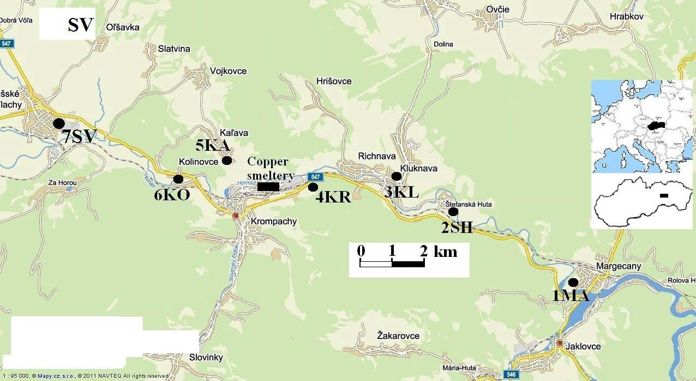
Fig. 1. Location of the sampling sites
Rys. 1. Miejsca pobierania próbek

Tab. 1. The emissions of particulate matter (PM) and metals from the Kovohuty, a.s. [t.year⁻¹]
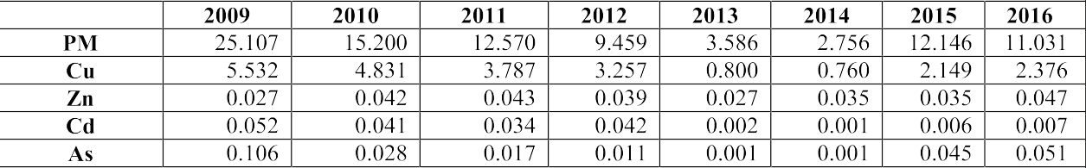Tab. 1. Emisja pyłu (PM) i metali z Kovohuty a.s. [t/rok]

area of Krompachy. The sampling sites were at a distance from 1.2 to 10 km from the main source of pollution (chim- ney of the copper smeltery). The localization of sampling sta- tions is illustrated in Fig. 1. The four sites were localised on a periphery of the villages away from small local emission sources and roads, at about 2.5 m above the ground: 1MA, 2SH, 4KR and 6KA. The stands of the sites 3KL, 7SV and 5KO were located on the roofs of buildings at 15 and 3 m above ground, respectively. The four open polyethylene cyl- inders (inside diameter – 12.5 cm) filled with 200 ml of pure deionized water fitted on a stand were used for sampling. In laboratory the contents of cylinders were filtered on a vacu- um filtration through 0.40 µm membrane filters to separate the “water soluble” and “insoluble” fractions (PM). The sol- uble fraction was analyzed after each sampling. The insolu- ble fraction for analysis was prepared by cumulation of six monthly samples into the one semi-annual sample – summer and winter period (mid-April – mid-October) and by miner- alization using a microwave digestion MWS-3 Berghof. The elements were analyzed by the atomic absorption spectrosco- py using the device VARIAN AA240 FS with GTA 120 and VGA-77. Since October 2012, the device ICP MS Agilent 7700 has been used for analysis. In the article are processed results of 8 winter and 7 summer periods from October 2009 to April 2017.

Results and discussion
Table 1 presents the average daily fluxes (μg.m⁻².day⁻¹) of observed elements and solid particles – PM (“water insolu- ble” part of AD) from total bulk deposition and basic statistic parameters for all sampling sites and the whole monitored period (September 2009 – April 2017). The abundance of el- ements (average) was represented in order Fe ≈ Al > Zn v Cu
> Pb > Mn > Cr > Cd ≈ As. The qualitative composition of at- mospheric deposition significantly contributed to the ecologi- cal load of the individual sampling points that was caused by smeltery activities. Among various sampling sites high dif- ferences in the deposition were determined mainly for lead, copper, zinc, cadmium and arsenic. The highest values of these elements were measured in the sampling sites localized in vicinity of the copper smeltery, i.e. 4KR, and 6KO in the
distance of 1.2 km and 2,4 km respectively. The lowest values of these elements were detected at the sampling site 1MA, that is furthest from the copper smeltery in the distance of 10 km. The average ratio between atmospheric deposition at the sites 4KR and 1MA (AD4KR/AD1MA) for the elements were in the range 3.8 to 10.9 (Pb = 10.9, Cu = 6.1, Cd = 6.0, Zn =
5.4 and As = 3.8). The relatively lower values of lead, cop- per and zinc were measured considering to the distance from the chimney (1.4 km) in the case of site 5KA. However, the site is outside the prevailing wind. In the area of Krompachy were not observed so high differences in the deposition of PM, iron, aluminum and manganese. In addition to the ex- pected high levels of deposition of copper, the above-average high deposition of lead, zinc and cadmium were measured in the area. The level of zinc deposition several times exceeds deposition of copper, which is sharply in contrast with the data of registered emissions by NEIS mentioned in the Table
1. Emissions of copper are in individual years approx. 30 to 200 times higher than zinc emissions. This disproportion is probably due to the significantly higher actual emissions of this element as registered emissions.
In table 3 is shown the average percentage representation of the deposition of trace elements bound to the “water-in- soluble” (PM) part of AD and the ratio between summer and winter atmospheric deposition of the monitored elements and PM. To the insoluble phase, the monitored elements in order of Al, Fe, Cr, Pb and As are bounded. The zinc, cadmium and a lesser extent of the copper were predominant bound on water soluble part of AD. The PM and elements: Al, Fe, As, Mn and Cr show a significantly higher presence in the summer period. The ratio between their deposition in sum- mer and winter is 4.3, 2.5, 2.4, 2.3, 1.9 and 1.6, respectively. There are better conditions for aeolian erosion and resuspen- sion of particles from soil horizon, road traffic, agricultural and construction activities. The increased presence of organic detritus in ambient air during the summer season also influ- ences the amount of dust particles. In winter, the deposition fluxes of solid particles are partially deprived of these effects. In the case of elements which probably come predominant- ly from copper smeltery relatively balanced values were recorded for both seasons. The average ratio was 0.9, 1.0,

Tab. 2. The average daily fluxes of particles (PM – insoluble fraction) and analyzed elements from 7 summer and 8 winter monitored periods (October 2009 – April 2017), [μg.m⁻².day⁻¹]. (*Finished April 2015, ** Finished October 2013)
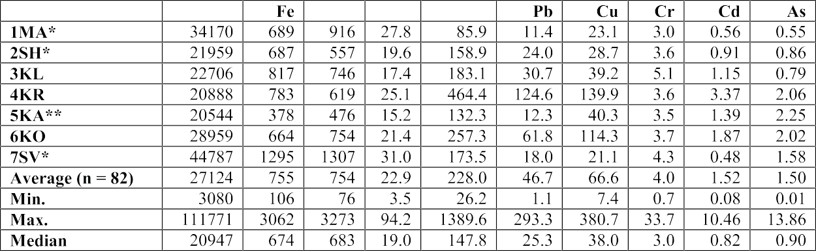Tab. 2. Średni dzienny opad cząstek (PM – frakcja nierozpuszczalna) i analizowane pierwiastki z 7 letnich i 8 zimowych okresów monitorowanych (październik 2009 – kwiecień 2017), [μg.m⁻².dzień ⁻¹]. (*Zakończone w kwietniu 2015 r., **Zakończone w październiku 2013 r.)

Tab. 3. The average element abundances in insoluble fraction [%] and the ratio between summer and winter atmospheric deposition of the observed elements and PM
Tab. 3. Średnie zawartości pierwiastków we frakcji nierozpuszczalnej [%]
oraz stosunek atmosferycznego opadu obserwowanych pierwiastków i pyłów w lecie i zimie

Tab. 4. The Pearson´s cross-correlation coefficients between fluxes of trace elements (n = 82) Tab. 4. Korelacja krzyżowa Pearsona między strumieniami pierwiastków śladowych (n = 82)

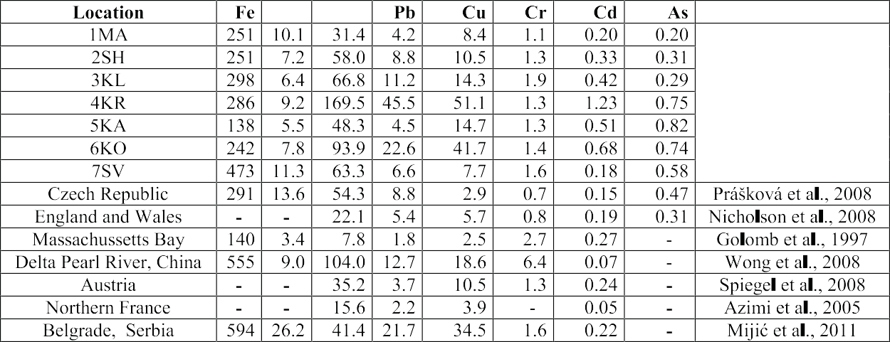Tab. 5. Comparison of annual deposition fluxes of the elements from different regions [mg.m⁻².yr⁻¹] Tab. 5. Porównanie rocznej wielkości opadów w różnych regionach [mg.m⁻².rok⁻¹]

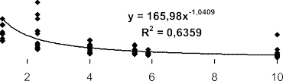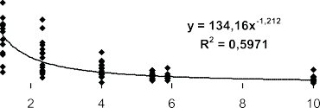

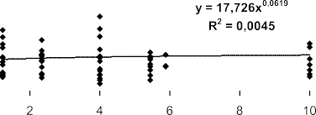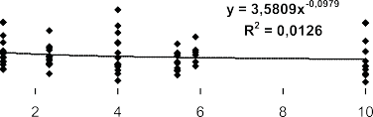
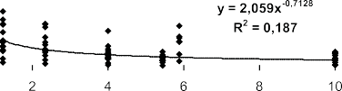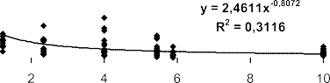

Fig. 2. The dependence between the deposition of the PM and observed elements and the distance from the copper smeltery Rys. 2. Zależności pomiędzy opadem pyłów I badanych pierwiastków w różnych odległościach od huty miedzi.

  - and 1.3 for the deposition fluxes of Pb, Cd, Cu and Zn, respectively.
The relationship between the deposition of the PM and observed elements and the distance from the smelter was studied by regression analysis from all measured period. The results are presented in Fig. 2. The dependence was found in descending order for the copper, lead, zinc, cadmium and par- tially for arsenic. For the other elements, no relationship was found between the distance from the main emission source and the deposition of these elements.
The statistical dependence between individual atmo- spheric deposition of observed metals and PM was evaluated by Pearson´s correlation analysis. The coefficients are sum- marized in Table 4. The high positive values of the correlation coefficient were found for two relatively independent groups of elements. The values of the correlation coefficients in the range 0.52 to 0.79 were calculated between elements Zn, Cd, Pb and Cu. In the second group between elements Fe, Mn, Al, and partially PM and Cr, correlation coefficients in the range 0.34 to 0.79 were found. Chromium has a relatively low positive correlation with the elements Fe, Mn, Al and PM: 0.32, 0.27, 0.23 and 0.17, respectively. In the case of el- ements of first group (Zn, Cd, Pb and Cu), the chromium has coefficients close to zero. The source of chromium in addition to soil horizon is probably a remote transmission of particles. The arsenic has a specific position, when it has positive cor- relation coefficients with all elements and PM in the range from 0.1 to 0.36. Thus, particles from contaminated soil hori-
zon due to historical mining and metallurgical activities can also be a source of arsenic in the area of Krompachy.
The deposition fluxes of the elements from this study are compared with results from other areas in Table 5. The depo- sition fluxes of Cd, Cu, Zn and Pb exceeded the correspond- ing data from these studies, especially at sites localized in the immediate vicinity of the copper smeltery (4KR, 6KO, 5KA).

Conclusion
Total atmospheric deposition i.e. the both wet and dry ones, was studied from seven sites in the area of copper smeltery in Krompachy from October 2009 to October 2017. The detailed analysis of deposition fluxes of selected ele- ments and particles showed a significant effect of the copper smeltery on qualitative and quantitative characteristics of at- mospheric deposition. In addition to the expected high levels of deposition of copper, the above-average high deposition of lead, zinc and cadmium were measured in comparison with different areas. The highest values of deposition fluxes of these elements were detected at sites near the copper smelt- ery. The level of zinc deposition disagrees with its registered emissions.

Acknowledgment
The authors are grateful to the Slovak Grant Agency for Science (Grant No. 2/0165/19) for financial support of the work.

Literatura – References
    - AZIMI, S.; ROCHER, V.; GARNAUD, S.; VARRAULT, G.; THEVENOT, D.R. Decrease of atmospheric deposition of heavy metals in an urban area from 1994 to 2002. Chemosphere. 2005, No. 6, p. 645-651. ISSN 0045-6535.
    - GOLOMB, D.; RYAN, D.; EBY, N.; UNDERHILL, J.; ZEMBA, S. Atmospheric deposition of toxic onto Massachu- setts Bay-I. Metals. Atmospheric Environment. 1997, Vol. 31, p. 1349-1359. ISSN 1352-2310.
    - HANČUĽÁK, J., FEDOROVÁ, E., ŠESTINOVÁ, O., ŠPALDON, T., MATIK, M. Influence of iron ore works in Nižná Slaná on atmospheric deposition of heavy metals. In Acta Montanistica Slovaca, 16, 2011, p. 220-228. ISSN 1335-1788.
    - HANČUĽÁK, J., KURBEL, T., KUPKA, D., ŠPALDON, T. ŠESTINOVÁ, O. - FINDORÁKOVÁ, L., FEDOROVÁ, E.. Influence of the Copper Smeltery in Krompachy (Slovakia) on Atmospheric Deposition. Inżynieria Mineralna, 15, 2014, p. 45-50. ISSN 1640-4920.
    - HANČUĽÁK, J. et al. Atmospheric Deposition of Solid Particles in the Area of Košice. Solid State Phenomena, 2016, vol. 244, p. 188-196.
    - KARA, M. et. al. Seasonal and spatial variations of atmospheric trace elemental deposition in the Aliaga ndustrial region, Turkey. In: Atmos. Res.149 (2014) 204–216.
    - MIJIĆ, Z., STOJIĆ, A., PERIŠIĆ, M., RAJŠIĆ, S., TASIĆ, M., RADENKOVIĆ, M., JOKSIĆ, J. Seasonal variability and source apportionment of metals in the atmospheric deposition in Belgrade. Atmospheric Environment, 44,3, 2010, 3630-3637.
    - MEHRAZIN, O., RUBAN, V., RUBAN, G., LAMPREA, K. Assessment of atmospheric trace metal deposition in urban environments using direct and indirect measurement methodology and contributions from wet and dry depositions Atmospheric Environment, 168 (2017), 101-111.
    - NEIS (Národný emisný informačný systém) [online]. c2015 [cit. 2018-04-18]. Dostupné z WWW: <http://www.air. sk (National Emission Information System of Slovak Republic)
    - NICOLÁS, J.F. et. al., 2008. Quantification of Saharan and local dust impact in an arid Mediterranean area by the positive matrix factorization (PMF) technique. Atmos. Environ. 42, 8872-8882.
    - NICHOLSON, F.A. et al. An inventory of heavy metals inputs to agricultural soils in England and Wales. Science of the Total Environment. 2003, Vol. 311, p. 205-219. ISSN 0048-9697.
    - PRÁŠKOVÁ, L.; KUBÍK, L.; MALÝ, S.: The control and extraneous matter monitoring in the farmlands and farm inputs. Annual report 2005. Central institute for supervising and testing in agriculture in Brno, 2006, p. 13.
    - PUTAUD, J.P. et al., 2010. A European aerosol phenomenology-3: physical and chemical characteristics of particu- late matter from 60 rural, urban, and kerbside sites across Europe. Atmos. Environ. 44, 1308-1320.
    - QUEROL, X. et. al. 2007. Source origin of trace elements in PM from regional background, urban and industrial sites of Spain. Atmos. Environ. 41, 7219-7231
    - SPIEGEL H., BÖHM K.E., ROTH K. SAGER, M. Atmospheric deposition of trace metals onto arable land in Austria. Proc. 7th Intern. Conf. On the Biogeochem. Of Trace Elements; Uppsala`03, 2003, p. 90.
    - WHO, 2013, Review of Evidence on Health Aspects of Air Pollution, REVIHAAP Project. final technical report., Copenhagen, Denmark. 302p.
    - WONG, C.S.C.; LI, X.D.; ZHANG, S.H.Qi.; PENG, X.Z. Atmospheric deposition of heavy metals in the Pearl River Delta, China. Atmospheric Environment. 2003, Vol. 37, p. 767-776. ISSN 1352-2310.
    - ZONGZE, C., YANG, Y., LU, J., ZHANG, C. Atmospheric particle characterization, distribution, and deposition in Xi’an, Shaanxi Province, Central China. In: Environ. Pollut. 159 (2011) 577-584.

